**Ideation Phase**

**Brainstorm & Idea Prioritization**

|  |  |
| --- | --- |
| Date | 07 October 2022 |
| Team ID | PNT2022TMID12996 |
| Project Name | Project – PLASMA DONOR APPLICATION |
| Maximum Marks | 4 Marks |

**Team Gathering, Problem Statement identification, Collaboration**

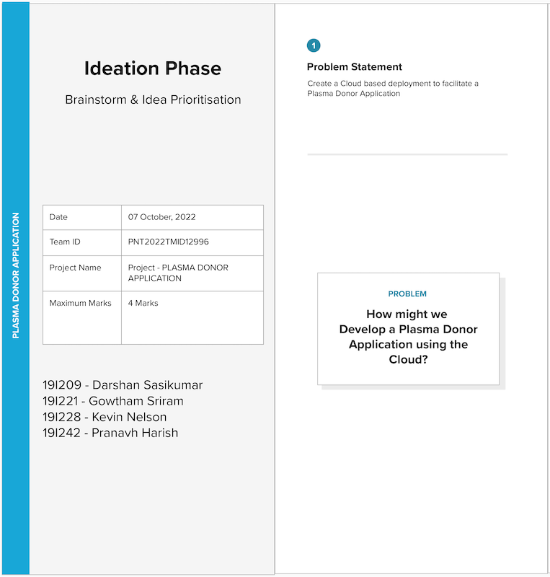

**Brainstorming, listing ideas, grouping**

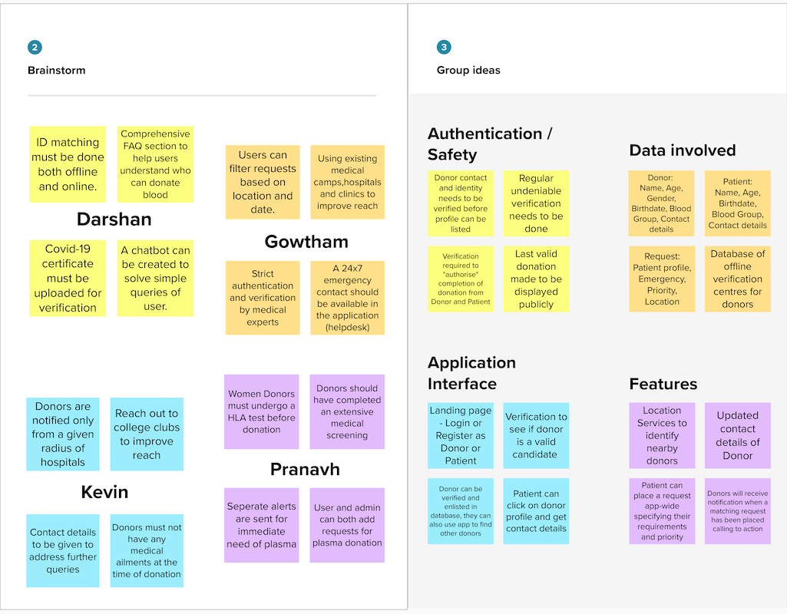

**Idea prioritization**

